This checklist records the monthly inspection of the Knapton Playground Area, which is required to;
- maintain the safety of those using the Play Area
- to demonstrate responsible duty of care for insurance purposes
It also looks at the entrance gate and the bench seat and identifies problems and issues found with the equipment and areas within the Playground, such as sharp edges, finger entrapments, broken or damaged items and playground’s general condition.
Person performing check: Date:
Signature: Time:
Please put a tick in the corresponding box as you complete each of the checks

Entry  Gate  checks | 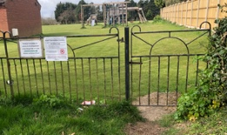 | Metalwork: fixings and footings free of damage, corrosion etc.  Fixings: are secure and undamaged with no sharp edges  Opens & closes: completely as should and be obstruction and vegetation free  Remove: any cable ties or similar

Bench  checks | 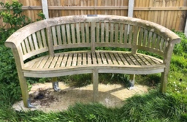 | Secure: Firmly fixed to the ground  Condition: Seat condition in good order and secure with no visual damage  Fixings and footings: free of damage, corrosion, vegetation etc.

Area  checks | 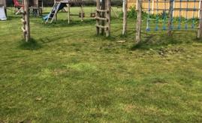 | Grassed area: free from debris, ruts and vegetation with no slippery areas, moss growth etc.  Boundary hedge: is clear of debris and not intruding on/over play area  No graffiti

Comments:

Unit 1  checks | 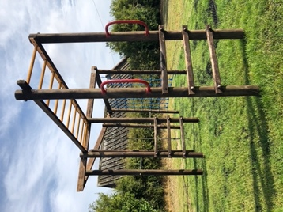 | Fall area: clear of debris, all fixings securely and in place and undamaged  Climbing Net: firmly fixed, fully intact, no loose strands  Climbing Chain: surface is smooth, tensioned and undamaged  Monkey Bars: intact, undamaged and rust free
Comments:

Unit 2  checks | 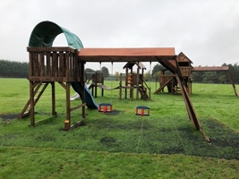 | Structure: is firmly fixed to ground, roof / canopy in good order, metalwork and paintwork in good order, fall area clear of debris  Ladder: is free of splinters and damage, all fixings securely and in place  Swings: all D-loops, fixings and chains in good order, baby seat condition in good order and secure  Slide: fixed firmly to structure and ground, all fixings securely and safely in place, slide surface smooth  Platform: is free of splinters and damage, no finger entrapments
Comments:

Unit 3  checks | 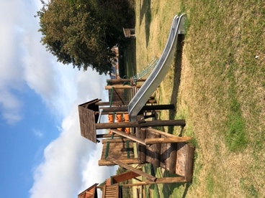 | Structure: is firmly fixed to ground, roof / canopy in good order, metalwork and paintwork in good order, fall area clear of debris  Ladder: is free of splinters and damage, all fixings securely in place  Swings: all D-loops, fixings and chains in good order, seat condition in good order and secure  Slide: fixed firmly to structure and ground, all fixings securely in place, slide surface smooth  Climbing Net: firmly fixed, fully intact, no loose strands and undamaged  Platform: is free of splinters and damage, no finger entrapments  OXO Rollers: in good working order, no damage, all fixings securely in place  Wood Walkway: is free of splinters and damage, no finger entrapments, all fixings securely in place
Comments:

Unit 4  checks | 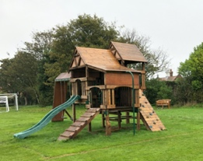 | Structure: is firmly fixed to ground, roof/canopy in good order, metalwork and paintwork in good order, fall area clear of debris, Grab handles all secure  Ladder: is free of splinters and damage, all fixings securely in place  Metal Slide Pole: is securely fixed to unit and ground, metalwork and paintwork in good order with no rust or sharp edges  Steppingstone Ramp: all handholds and footings are fixed, firm, secure and safe, ramp is free of splinters and damage  Swings: all D-loops, fixings and chains in good order, seat condition in good order and secure  Slide: is fixed firmly to structure and ground, all fixings securely in place, slide surface smooth  Platform: is free of splinters and damage, no finger entrapments
Comments:

Other general comments
Please feel free to add any additional comments, photos or diagrams related to maintaining the Playground in good order, highlighting those which you feel require urgent attention.
Comments:

